Rambo Stickman Report

Created by

Thanadol Rungjitwaranon 6031018121

[Tanawit Kritwongwiman](https://www.facebook.com/kaoths?__tn__=K-R&eid=ARCIobXYA5KgVN77pt4kpeICUVykyIaoKcSHnuI_Bn9H0LT13Xd7FkofXhm4NYRlgEw9ajH_RrRSFSiK&fref=mentions&__xts__%5B0%5D=68.ARCtl7E2o-3RAPGIZ0BNB4-wqMpyv-LYhbzJ7PViNGTp7Ha66pvshHnJGo16VSRTIrgeWkWaXuVPTd9-sldUqjZoy0Cs6vCfP4Kh1_TDavFCVT1YN2picTZX4XrSiIfKO9LbDu3NZ4_XnrI9xTZqANch2K_fk96SbLxTmqN10ughONCdV6UbPi7xbUZEcbALHmqfWIQSxPwCDYcB83OFpOaRTrCqoViQ8UzCvpF1Mynd7m7__R0-KVHTykq6Hm0rvEZ-6JEtdbVHMj-dsyTIHGSmRzq4PSjQFU7P40F8306Qi-3uy3Vww8qvMYpAPcVxog7Vq9haU0Ty2qYckLqdFXQ5-l2uPDzShQ) 6031021021

2110215

Programming Methodology

Semester 1 Year 2018

Introduction

Rambo Stickman is a fighting game which you can punch or kick. This game’s goal is to survive and get the score as high as you can. There are 3 different enemies, Grey, Red, and Blue. Grey enemy has nothing special while Red is superior in attack power but weak in defense. Blue, on the other hand, is superior in defense and weak in offense. In the game there will be 4 buffs to help you. First, damage buff, this buff will increase your damage so you can kill enemy more easily. Second, defense buff, this make you more tough against enemy attacks. Third, speed buff, this increase walk speed so you can rotate around the map quicker. Fourth, healing buff, this buff recovers you 20% of your max hp. However, there is an obstacle in this game, the missiles. Missiles will randomly launch and you need to evade them by crouching, is you’re hit the missile deal damage equal to 20% of your current hp.

User guide

Start Scene

**Click ‘NEW GAME’ and enter player’s name.**

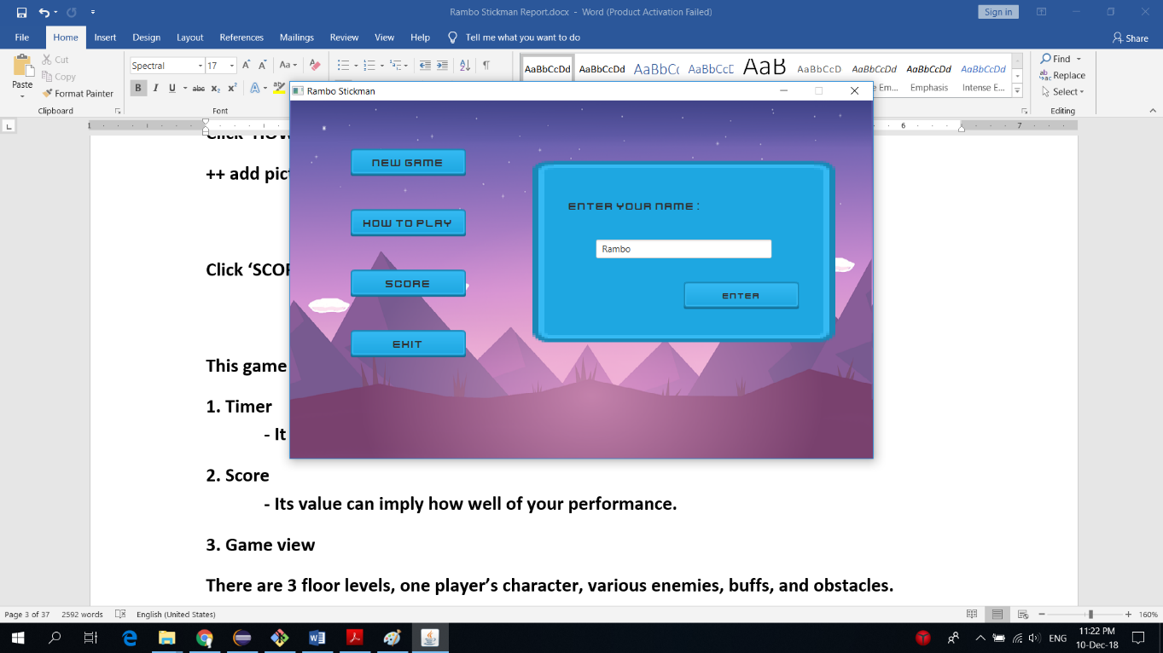

Instruction Scene

**Click ‘HOW TO PLAY’ to learn how to control your stickman.** 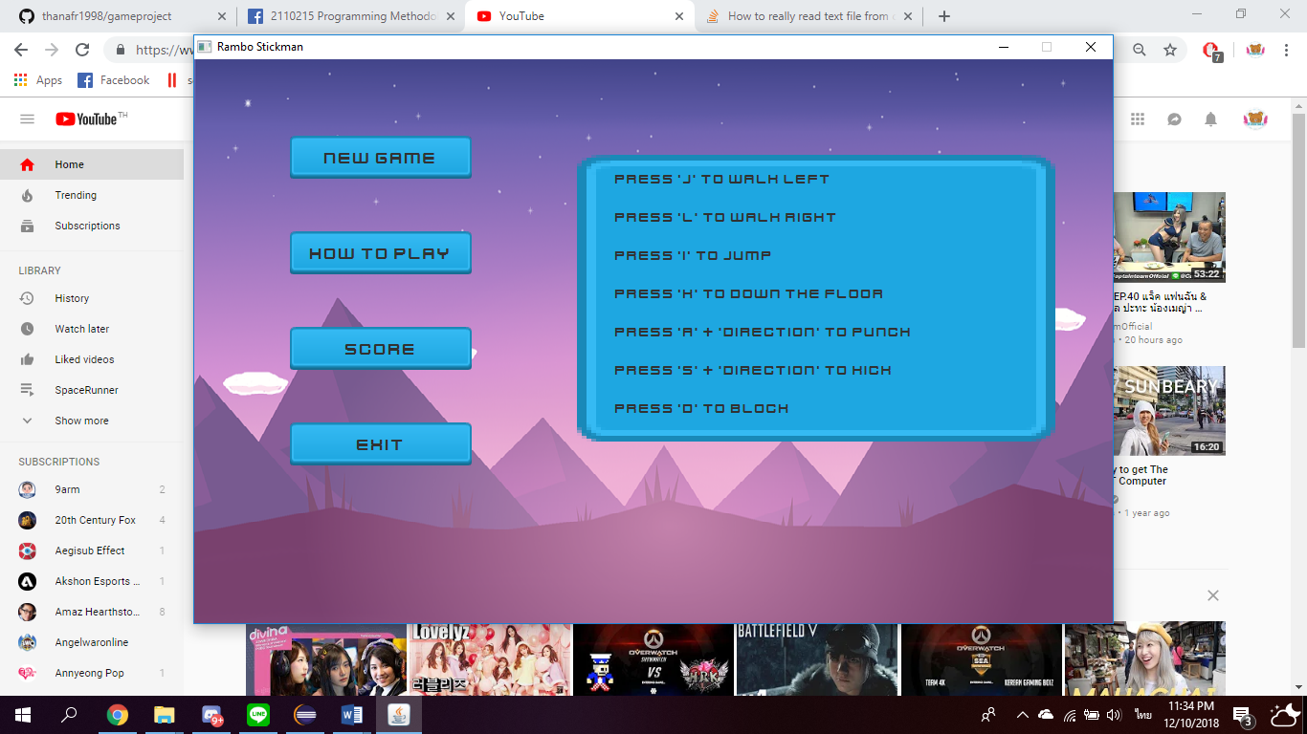

High-score Scene

**Click ‘SCORE’ to see the highest score.**

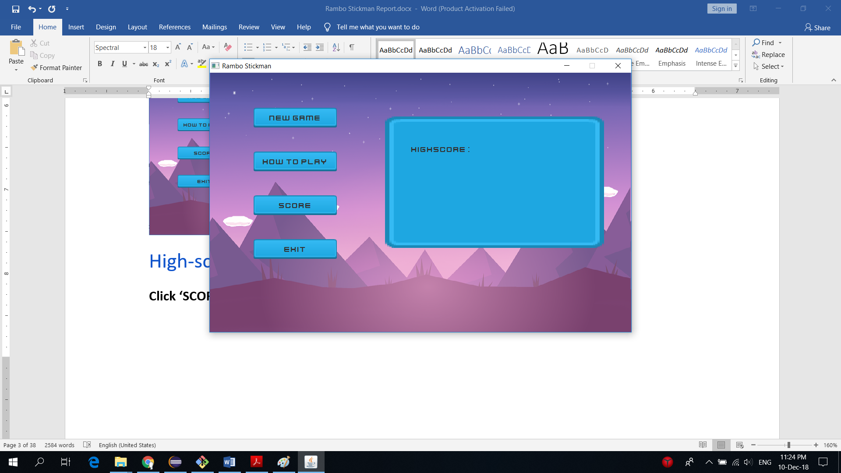

In-game Scene

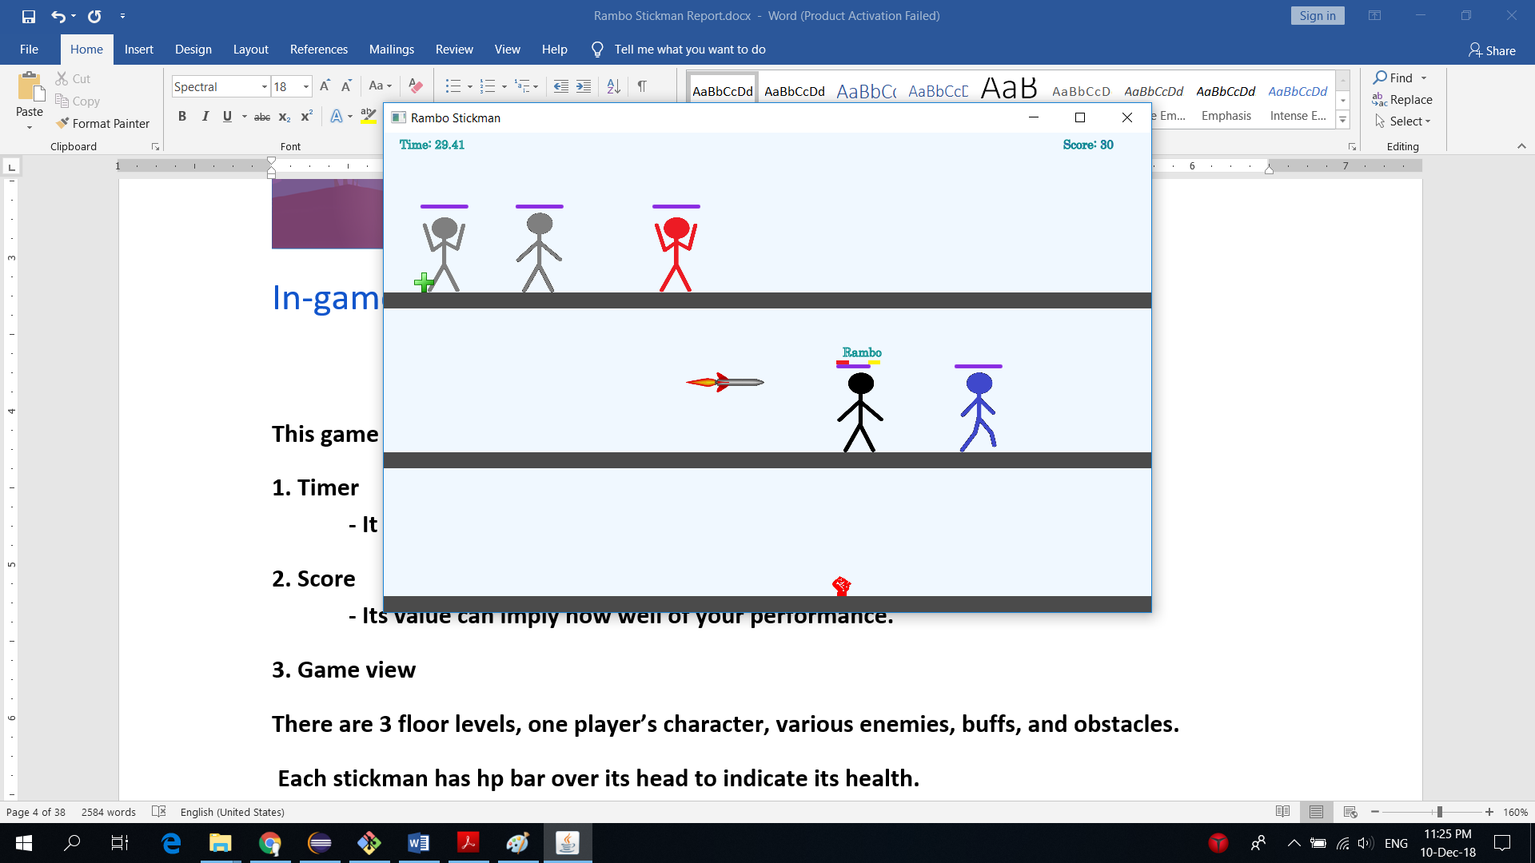

**This game consists of 3 components: Timer, Score, and Game view.**

**1. Timer   
 - It shows the time passed in seconds.**

**2. Score  
 - Its value can imply how well of your performance.**

**3. Game view**

**There are 3 floor levels, one player’s character, various enemies, buffs, and obstacles.**

**Each stickman has hp bar over its head to indicate its health.**

**Player’s stickman, however, has additional name and buff’s duration indicators.**

Characters

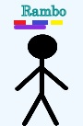**Player’s stickman.**

Player’s name

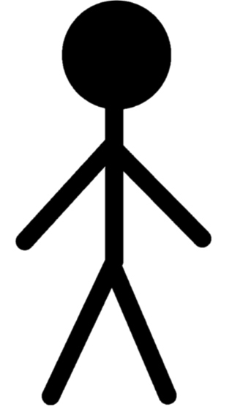

Player’s health bar

Buff duration indicator

**Basic statuses:  
Color: Black  
Max health: 2000  
Punch damage: 75  
Kick damage: 40  
Defense: 0  
Walk speed: 6**

**Controlling**

**Move left: key “J”**

**Move right: key “L”**

**Jump up: key “I”**

**Drop down: key “K”**

**Punch: key “A” *must combine with move keys to indicate attack direction.**

**Kick: key “S” *must combine with move keys to indicate attack direction.**

**Block: key “D” *block state negates punch damage, but not kick damage.**

**Crouch: key “C” *crouch mainly use for evading obstacle missiles.**

**Enemies’ stickman**

**Grey stickman Red stickman Blue stickman**

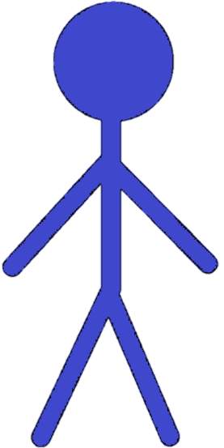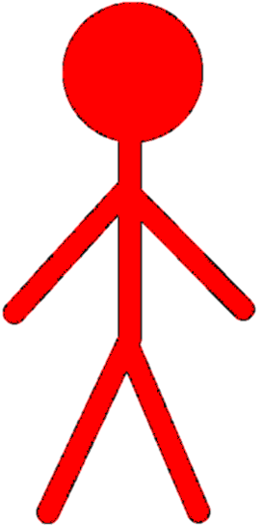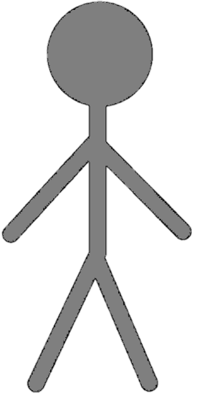

**Basic statuses: Basic statuses: Basic statuses:**

**Color: Grey Color: Red Color: Blue**

**Max health: 750 Max health: 250 Max health: 1500**

**Punch damage: 75 Punch damage: 120 Punch damage: 30**

**Kick damage: 40 Kick damage: 70 Kick damage: 15**

**Defense: 0 Defense: 0 Defense: 30**

**Walk speed: 1 Walk speed: 8 Walk speed: 0.3**

**Strength: None Strength: Attack, Fast Strength: Toughness**

**Weakness: None Weakness: low health Weakness: ATK/Slow**

Buffs and obstacles

**Buffs** (noted: every buff last for 5 seconds)



**Damage Buff: Increase punch damage by 35 and kick damage by 45 and kick damage by 20**



**Defense Buff: Increase defense by 30**



**Speed Buff: Increase walk speed by 4**



**Heal Buff: Instantly heal 20% of player’s max health**

**Obstacles**



**Missile: Upon hit, deal damage to player equal to 20% of player current health**

**Evading: Crouch to evade**

**Noted: Missile cannot be blocked or destroyed.**

Implementation Details

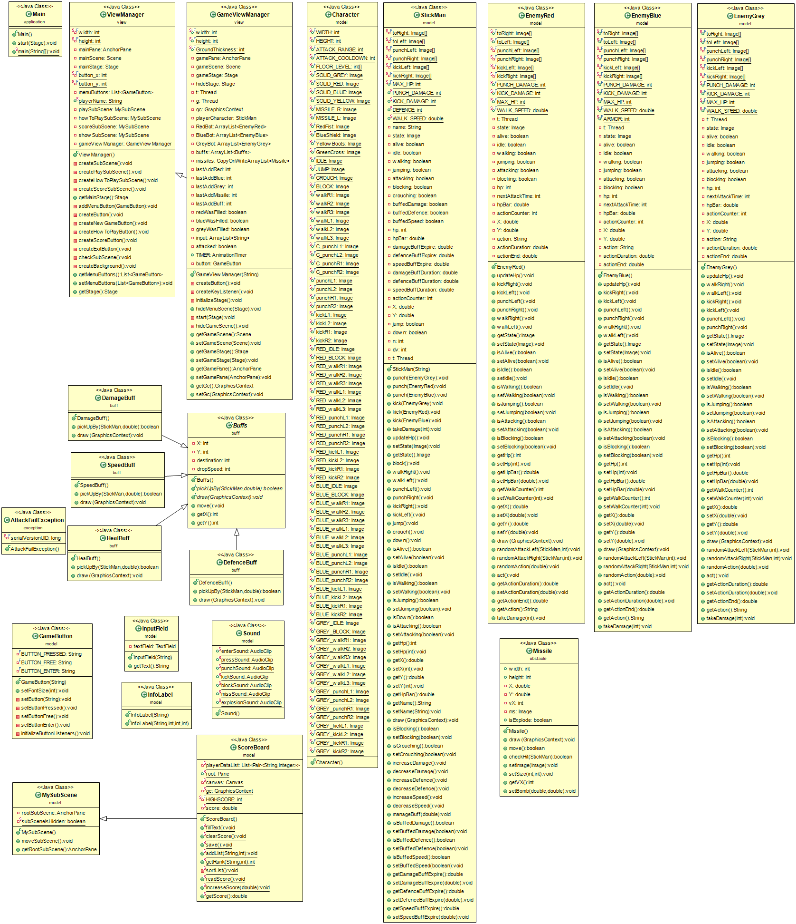

UML

UML

* Noted that Access Modifier Notations can be listed below

+ (public)

# (protected)

- (private)

static will be underlined.

abstract will be italic

**1. Package application**

**1.1 Class Main extends Application**

1.1.1 Method

|  |  |
| --- | --- |
| + void main(String[] args) | - An entry point of the application |
| + void start(Stage primaryStage) | - The main entry point of the JavaFX application |

**2. Package buff**

**2.1 Class *Buffs***

2.1.1 Field

|  |  |
| --- | --- |
| - int X ,Y , destination | - Position that the buff fall |
| - int dropSpeed | - Speed of falling buff |

2.1.2 Constructor

|  |  |
| --- | --- |
| + Buffs() | - Initialise field and set default value to variable |

2.1.3 Method

|  |  |
| --- | --- |
| + *boolean pickUpBy(StickMan sm, double pickTime)* | - Check that buff is picked up |
| + *void draw(GraphicsContext gc)* | - Draw things on the canvas |
| + void move() | - Set buff move path |
| + int getX() | - Return buff position on x-axis |
| + int getY() | - Return buff position on y-axis |

**2.2 Class DamageBuff extends Buffs**

2.2.1 Constructor

|  |  |
| --- | --- |
| + DamageBuff() | - Call super class costructor |

2.2.2 Method

|  |  |
| --- | --- |
| + *boolean pickUpBy(StickMan sm, double pickTime)* | - Override method and give player more damage deal |
| + *void draw(GraphicsContext gc)* | - Override method and draw damage buff picture |

**2.3 Class DefenceBuff extends Buffs**

2.3.1 Constructor

|  |  |
| --- | --- |
| + DefenceBuff() | - Call super class costructor |

2.3.2 Method

|  |  |
| --- | --- |
| + *boolean pickUpBy(StickMan sm, double pickTime)* | - Override method and give player more defence |
| + *void draw(GraphicsContext gc)* | - Override method and draw defence buff picture |

**2.4 Class HealBuff extends Buffs**

2.4.1 Constructor

|  |  |
| --- | --- |
| + HealBuff() | - Call super class costructor |

2.4.2 Method

|  |  |
| --- | --- |
| + *boolean pickUpBy(StickMan sm, double pickTime)* | - Override method and give player more heal |
| + *void draw(GraphicsContext gc)* | - Override method and draw heal buff picture |

**2.5 Class SpeedBuff extends Buffs**

2.5.1 Constructor

|  |  |
| --- | --- |
| + SpeedBuff() | - Call super class costructor |

2.5.2 Method

|  |  |
| --- | --- |
| + *boolean pickUpBy(StickMan sm, double pickTime)* | - Override method and give player more spped |
| + *void draw(GraphicsContext gc)* | - Override method and draw speed buff picture |

**3. Package exception**

**3.1 Class AttackFailException extends Exception**

3.1.1 Field

|  |  |
| --- | --- |
| - long serialVersionUID | - 6466107723056783598L |

**4. Package model**

**4.1 Class Character**

4.1.1 Field

|  |  |
| --- | --- |
| + final int WIDTH | - Size of stickman on x-axis |
| + final int HEIGHT | - Size of stickman on y-axis |
| + final int ATTACK_RANGE | - Distance that attack will do damage |
| + final int ATTACK_COOLDOWN | - Cooldown on attack |
| + final int[] FLOOR_LEVEL | - Store position of each floor on y-axis |
| + final Image SOLID_GREY | - Image of grey square |
| + final Image SOLID_RED | - Image of red square |
| + final Image SOLID_BLUE | - Image of blue square |
| + final Image SOLID_YELLOW | - Image of yellow square |
| + final Image MISSILE_R | - Image of missile which head to right |
| + final Image MISSILE_L | - Image of missile which head to left |
| + final Image RedFist | - Image of damage buff |
| + final Image BlueShield | - Image of defence buff |
| + final Image YellowBoots | - Image of speed buff |
| + final Image GreenCross | - Image of heal buff |
| + final Image IDLE | - Image of normal stickman |
| + final Image JUMP | - Image of jumping stickman |
| + final Image CROUCH | - Image of crouching stickman |
| + final Image BLOCK | - Image of blocking stickman |
| + final Image walkR1 | - Image of walking right stickman(first step) |
| + final Image walkR2 | - Image of walking right stickman(second step) |
| + final Image walkR3 | - Image of walking right stickman(third step) |
| + final Image walkL1 | - Image of walking left stickman(first step) |
| + final Image walkL2 | - Image of walking left stickman(second step) |
| + final Image walkL3 | - Image of walking left stickman(third step) |
| + final Image C_punchL1 | - Image of crouching right punch stickman(first step) |
| + final Image C_punchL2 | - Image of crouching right punch stickman(second step) |
| + final Image C_punchL3 | - Image of crouching right punch stickman(third step) |
| + final Image punchL1 | - Image of left punch stickman(first step) |
| + final Image punchL2 | - Image of left punch stickman(second step) |
| + final Image punchR1 | - Image of right punch stickman(first step) |
| + final Image punchR2 | - Image of right punch stickman(second step) |
| + final Image kickL1 | - Image of left kick stickman(first step) |
| + final Image kickL2 | - Image of left kick stickman(second step) |
| + final Image kickR1 | - Image of right kick stickman(first step) |
| + final Image kickR2 | - Image of right kick stickman(second step) |
| + final Image RED_IDLE | - Image of normal red stickman |
| + final Image RED_BLOCK | - Image of blocking red stickman |
| + final Image RED_walkR1 | - Image of walking right red stickman(first step) |
| + final Image RED_walkR2 | - Image of walking right red stickman(second step) |
| + final Image RED_walkR3 | - Image of walking right red stickman(third step) |
| + final Image RED_walkL1 | - Image of walking left red stickman(first step) |
| + final Image RED_walkL2 | - Image of walking left red stickman(second step) |
| + final Image RED_walkL3 | - Image of walking left red stickman(third step) |
| + final Image RED_punchL1 | - Image of left punch red stickman(first step) |
| + final Image RED_punchL2 | - Image of left punch red stickman(second step) |
| + final Image RED_punchR1 | - Image of right punch red stickman(first step) |
| + final Image RED_punchR2 | - Image of right punch red stickman(second step) |
| + final Image RED_kickL1 | - Image of left kick red stickman(first step) |
| + final Image RED_kickL2 | - Image of left kick red stickman(second step) |
| + final Image RED_kickR1 | - Image of right kick red stickman(first step) |
| + final Image RED_kickR2 | - Image of right kick red stickman(second step) |
| + final Image BLUE_IDLE | - Image of normal blue stickman |
| + final Image BLUE_BLOCK | - Image of blocking blue stickman |
| + final Image BLUE_walkR1 | - Image of walking right blue stickman(first step) |
| + final Image BLUE_walkR2 | - Image of walking right blue stickman(second step) |
| + final Image BLUE_walkR3 | - Image of walking right blue stickman(third step) |
| + final Image BLUE_walkL1 | - Image of walking left blue stickman(first step) |
| + final Image BLUE_walkL2 | - Image of walking left blue stickman(second step) |
| + final Image BLUE_walkL3 | - Image of walking left blue stickman(third step) |
| + final Image BLUE_punchL1 | - Image of left punch blue stickman(first step) |
| + final Image BLUE_punchL2 | - Image of left punch blue stickman(second step) |
| + final Image BLUE_punchR1 | - Image of right punch blue stickman(first step) |
| + final Image BLUE_punchR2 | - Image of right punch blue stickman(second step) |
| + final Image BLUE_kickL1 | - Image of left kick blue stickman(first step) |
| + final Image BLUE_kickL2 | - Image of left kick blue stickman(second step) |
| + final Image BLUE_kickR1 | - Image of right kick blue stickman(first step) |
| + final Image BLUE_kickR2 | - Image of right kick blue stickman(second step) |
| + final Image GREY_IDLE | - Image of normal grey stickman |
| + final Image GREY_BLOCK | - Image of blocking grey stickman |
| + final Image GREY_walkR1 | - Image of walking right grey stickman(first step) |
| + final Image GREY_walkR2 | - Image of walking right grey stickman(second step) |
| + final Image GREY_walkR3 | - Image of walking right grey stickman(third step) |
| + final Image GREY_walkL1 | - Image of walking left grey stickman(first step) |
| + final Image GREY_walkL2 | - Image of walking left grey stickman(second step) |
| + final Image GREY_walkL3 | - Image of walking left grey stickman(third step) |
| + final Image GREY_punchL1 | - Image of left punch grey stickman(first step) |
| + final Image GREY_punchL2 | - Image of left punch grey stickman(second step) |
| + final Image GREY_punchR1 | - Image of right punch grey stickman(first step) |
| + final Image GREY_punchR2 | - Image of right punch grey stickman(second step) |
| + final Image GREY_kickL1 | - Image of left kick grey stickman(first step) |
| + final Image GREY_kickL2 | - Image of left kick grey stickman(second step) |
| + final Image GREY_kickR1 | - Image of right kick grey stickman(first step) |
| + final Image GREY_kickR2 | - Image of right kick grey stickman(second step) |

**4.2 Class EnemyBlue**

4.2.1 Field

|  |  |
| --- | --- |
| + final Image[] toRight | - Store image head of right blue stickman |
| + final Image[] toLeft | - Store image head left of blue stickman |
| - final Image[] punchLeft | - Store image punch left of blue stickman |
| - final Image[] punchRight | - Store image punch right of blue stickman |
| - final Image[] kickLeft | - Store image punch kick of blue stickman |
| - final Image[] kickRight | - Store image punch kick of blue stickman |
| + final int PUNCH_DAMAGE | - Damage punch of blue stickman |
| + final int KICK_DAMAGE | - Damage kick of blue stickman |
| + final int MAX_HP | - Health of blue stickman |
| + final double WALK_SPEED | - Speed of blue stickman |
| + final int ARMOR | - Armor of blue stickman |
| - Thread t | - New thread |
| - Image state | - Image of current state |
| - boolean alive, idle, walking, jumping, attacking, blocking | - Boolean to check state |
| - int hp, nextAttackTime | - Current hp and next time to attack |
| - double hpBar | - Hp bar |
| - int actionCounter | - Integer to change the state |
| - double X, Y | - Current position on x-axis and y-axis |
| - String action | - Action that blue stickman do |
| - double actionDuration | - Duration that take from action |
| - double actionEnd | - Time that finishing action |

4.2.2 Constructor

|  |  |
| --- | --- |
| + EnemyBlue() | - Initialise field and set default value to variable |

4.2.3 Method

|  |  |
| --- | --- |
| + void updateHP() | - Current hp of blue stickman |
| + void kickRight() | - Set picture when blue stickman kick right |
| + void kickLeft() | - Set picture when blue stickman kick left |
| + void punchRight() | - Set picture when blue stickman punch right |
| + void punchLeft() | - Set picture when blue stickman punch left |
| + void walkRight() | - Set picture when blue stickman walk right |
| + void walkLeft() | - Set picture when blue stickman walk left |
| + void getter,setter | state, alive, idle, walking, jumping, attacking, blocking, hp, hpBar, walkCounter, X, Y, action, actionDuration, actionEnd |
| + void draw(GraphicsContext gc) | - Draw image on canvas |
| + void randomAttackLeft(StickMan sm, int attackTime) | - Set random attack left when player at the left of blue stickman |
| + void randomAttackRight(StickMan sm, int attackTime) | - Set random attack right when player at the right of blue stickman |
| + void randomAction(double startTime) | - Set random blue stickman action |
| + void act() | - Set blue stickman action |
| + void takeDamage(int damage) | - Set new hp of blue stickman when get hit |

**4.3 Class EnemyGrey**

4.3.1 Field

|  |  |
| --- | --- |
| + final Image[] toRight | - Store image head of right grey stickman |
| + final Image[] toLeft | - Store image head left of grey stickman |
| - final Image[] punchLeft | - Store image punch left of grey stickman |
| - final Image[] punchRight | - Store image punch right of grey stickman |
| - final Image[] kickLeft | - Store image punch kick of grey stickman |
| - final Image[] kickRight | - Store image punch kick of grey stickman |
| + final int PUNCH_DAMAGE | - Damage punch of grey stickman |
| + final int KICK_DAMAGE | - Damage kick of grey stickman |
| + final int MAX_HP | - Health of grey stickman |
| + final double WALK_SPEED | - Speed of grey stickman |
| - Thread t | - New thread |
| - Image state | - Image of current state |
| - boolean alive, idle, walking, jumping, attacking, blocking | - Boolean to check state |
| - int hp, nextAttackTime | - Current hp and next time to attack |
| - double hpBar | - Hp bar |
| - int actionCounter | - Integer to change the state |
| - double X, Y | - Current position on x-axis and y-axis |
| - String action | - Action that blue stickman do |
| - double actionDuration | - Duration that take from action |
| - double actionEnd | - Time that finishing action |

4.3.2 Constructor

|  |  |
| --- | --- |
| + EnemyGrey() | - Initialise field and set default value to variable |

4.3.3 Method

|  |  |
| --- | --- |
| + void updateHP() | - Current hp of grey stickman |
| + void kickRight() | - Set picture when grey stickman kick right |
| + void kickLeft() | - Set picture when grey stickman kick left |
| + void punchRight() | - Set picture when grey stickman punch right |
| + void punchLeft() | - Set picture when grey stickman punch left |
| + void walkRight() | - Set picture when grey stickman walk right |
| + void walkLeft() | - Set picture when grey stickman walk left |
| + void getter,setter | state, alive, idle, walking, jumping, attacking, blocking, hp, hpBar, walkCounter, X, Y, action, actionDuration, actionEnd |
| + void draw(GraphicsContext gc) | - Draw image on canvas |
| + void randomAttackLeft(StickMan sm, int attackTime) | - Set random attack left when player at the left of grey stickman |
| + void randomAttackRight(StickMan sm, int attackTime) | - Set random attack right when player at the right of grey stickman |
| + void randomAction(double startTime) | - Set random grey stickman action |
| + void act() | - Set grey stickman action |
| + void takeDamage(int damage) | - Set new hp of grey stickman when get hit |

**4.4 Class EnemyRed**

4.4.1 Field

|  |  |
| --- | --- |
| + final Image[] toRight | - Store image head of right red stickman |
| + final Image[] toLeft | - Store image head left of red stickman |
| - final Image[] punchLeft | - Store image punch left of red stickman |
| - final Image[] punchRight | - Store image punch right of red stickman |
| - final Image[] kickLeft | - Store image punch kick of red stickman |
| - final Image[] kickRight | - Store image punch kick of red stickman |
| + final int PUNCH_DAMAGE | - Damage punch of red stickman |
| + final int KICK_DAMAGE | - Damage kick of red stickman |
| + final int MAX_HP | - Health of red stickman |
| + final double WALK_SPEED | - Speed of red stickman |
| - Thread t | - New thread |
| - Image state | - Image of current state |
| - boolean alive, idle, walking, jumping, attacking, blocking | - Boolean to check state |
| - int hp, nextAttackTime | - Current hp and next time to attack |
| - double hpBar | - Hp bar |
| - int actionCounter | - Integer to change the state |
| - double X, Y | - Current position on x-axis and y-axis |
| - String action | - Action that red stickman do |
| - double actionDuration | - Duration that take from action |
| - double actionEnd | - Time that finishing action |

4.4.2 Constructor

|  |  |
| --- | --- |
| + EnemyRed() | - Initialise field and set default value to variable |

4.4.3 Method

|  |  |
| --- | --- |
| + void updateHP() | - Current hp of red stickman |
| + void kickRight() | - Set picture when red stickman kick right |
| + void kickLeft() | - Set picture when red stickman kick left |
| + void punchRight() | - Set picture when red stickman punch right |
| + void punchLeft() | - Set picture when red stickman punch left |
| + void walkRight() | - Set picture when red stickman walk right |
| + void walkLeft() | - Set picture when red stickman walk left |
| + getter,setter | state, alive, idle, walking, jumping, attacking, blocking, hp, hpBar, walkCounter, X, Y, action, actionDuration, actionEnd |
| + void draw(GraphicsContext gc) | - Draw image on canvas |
| + void randomAttackLeft(StickMan sm, int attackTime) | - Set random attack left when player at the left of red stickman |
| + void randomAttackRight(StickMan sm, int attackTime) | - Set random attack right when player at the right of red stickman |
| + void randomAction(double startTime) | - Set random red stickman action |
| + void act() | - Set red stickman action |
| + void takeDamage(int damage) | - Set new hp of red stickman when get hit |

**4.5 Class GameButton extends Button**

4.5.1 Field

|  |  |
| --- | --- |
| - final String BUTTON_PRESSED | - String of image button pressed |
| - final String BUTTON_FREE | - String of image button free |
| - final String BUTTON_ENTER | - String of image button when cursor enter |

4.5.2 Constructor

|  |  |
| --- | --- |
| + GameButton(String text) | - Call super class costructor, set default value to variable and set text on button |

4.5.3 Method

|  |  |
| --- | --- |
| + void setFontSize(int size) | - Set size text on button |
| - void setButton(String style) | - Set font text on button |
| - void setButtonPressed() | - Set image pressed button |
| - void setButtonFree() | - Set image free button |
| - void setButtonEnter() | - Set image enter button |
| - void initializeButtonListeners() | - Set action when click and set sound |

**4.6 Class InfoLabel extends Label**

4.6.1 Constructor

|  |  |
| --- | --- |
| + InfoLabel(String text) | - Call super class constructor and set text |
| + InfoLabel(String text, int width, int height) | **-** Call super class constructor and set text with width and height |

**4.7 Class InputField extends VBox**

4.7.1 Field

|  |  |
| --- | --- |
| - TextField textField | - Receive input text |

4.7.2 Constructor

|  |  |
| --- | --- |
| + InputField(String prompText) | - Call super class constructor and set promptext |

4.7.3 Method

|  |  |
| --- | --- |
| + String getText() | - return text from input |

**4.8 Class MySubScene extends SubScene**

4.8.1 Field

|  |  |
| --- | --- |
| - AnchorPane rootSubScene | - Pane that contain things |
| - *boolean subSceneIsHidden* | - Check that subscene show or not |

4.8.2 Constructor

|  |  |
| --- | --- |
| + MySubScene() | - Call super class constructor and setdefault value to variable |

4.8.3 Method

|  |  |
| --- | --- |
| + void moveSubScene() | - Make animation move subscene |
| - AnchorPane getRootSubScene() | - return Pane |

**4.9 Class ScoreBoard extends MySubScene**

4.9.1 Field

|  |  |
| --- | --- |
| - List<Pair<String, Integer>> | - |
| + Pane root | - |
| - Canvas canvas | - Canvas for draw |
| - GraphicsContext gc | - |
| - final int HIGHSCORE = 5 | - Max player in scoreboard |
| - double score | - Current score |

4.9.2 Constructor

|  |  |
| --- | --- |
| + ScoreBoard() | - Call super class constructor and setdefault value to variable |

4.9.3 Method

|  |  |
| --- | --- |
| + void fillText() | **?** |
| + void clearScore() throws FileNotFoundException, UnsupportedEncodingException |  |
| + void save() |  |
| + void addList(String playerName, int score) |  |
| + int getRank(String playerName, int score) |  |
| - void sortList() |  |
| + void readScore() |  |
| + void increaseScore(double point) |  |
| + double getScore() |  |

**4.10 Class Sound**

4.10.1 Field

|  |  |
| --- | --- |
| + AudioClip enterSound | **?** |
| + AudioClip pressSound | **?** |
| + AudioClip punchSound | **?** |
| + AudioClip kickSound | **?** |
| + AudioClip blockSound | **?** |
| + AudioClip missSound | **?** |
| + AudioClip explosionSound | **?** |

**4.11 Class StickMan**

4.11.1 Field

|  |  |
| --- | --- |
| + final Image[] toRight | **?** |
| + final Image[] toLeft | **?** |
| - final Image[] punchLeft | **?** |
| - final Image[] punchRight | **?** |
| - final Image[] kickLeft | **?** |
| - final Image[] kickRight | **?** |
| + int PUNCH_DAMAGE | **?** |
| + int KICK_DAMAGE | **?** |
| + final int MAX_HP | **?** |
| + double WALK_SPEED | **?** |
| + int DEFENCE | **?** |
| - String name | **?** |
| - Image state | **?** |
| - boolean alive, idle, walking, jumping, attacking, blocking, crouching | **?** |
| - boolean buffedDamage, buffedDefence, speedBuffDuration | **?** |
| - int hp | **?** |
| - double hpBar, damageBuffExpire, defenceBuffExpire, speedBuffExpire | **?** |
| - double damageBuffDuration, defenceBuffDuration, speedBuffDuration | **?** |
| - int actionCounter | **?** |
| - double X, Y | **?** |
| - boolean jump, down | **?** |
| - int n, dv | **?** |
| - Thread t | **?** |

4.11.2 Constructor

|  |  |
| --- | --- |
| + StickMan(String name) | - Initialise field and set default value to variable and add name |

4.11.3 Method

|  |  |
| --- | --- |
| + void punch(EnemyGrey target) | **?** |
| + void punch(EnemyRed target) | **?** |
| + void punch(EnemyBlue target) | **?** |
| + void kick(EnemyGrey target) | **?** |
| + void kick(EnemyRed target) | **?** |
| + void kick(EnemyBlue target) | **?** |
| + void takeDamage(int hp) | ? |
| + void updateHp() | ? |
| + void block() | ? |
| + void walkRight() | ? |
| + void walkLeft() | ? |
| + void punchRight() | ? |
| + void punchLeft() | ? |
| + void kickRight() | ? |
| + void kickLeft() | ? |
| + void jump() | ? |
| + void crouch() | ? |
| + void down() | ? |
| + void draw(GraphicsContext gc) | ? |
| + void increaseDamage() | ? |
| + void decreaseDamage() | ? |
| + void increaseDefence() | ? |
| + void decreaseDefence() | ? |
| + void increaseSpeed() | ? |
| + void decreaseSpeed() | ? |
| + void manageBuff(double time) | ? |
| + getter,setter | state, alive, idle, walking, jumping, down, attacking, blocking, crouching, hp, hpBar, X, Y, name, buffedDamage, buffedDefence, buffedSpeed, damageBuffExpire, defenceBuffExpire, speedBuffExpire |

**5. Package obstacle**

**5.1 Class Missile**

5.1.1 Field

|  |  |
| --- | --- |
| + int width | **?** |
| +int height | **?** |
| - double X, Y | **?** |
| - int vX | **?** |
| - Image ms | **?** |
| + boolean isExplode | **?** |

5.1.2 Constructor

|  |  |
| --- | --- |
| + Missile() | - Initialise field and set default value to variable |

5.1.3 Method

|  |  |
| --- | --- |
| + void draw(GraphicsContext gc) | ? |
| + void move() | ? |
| + boolean checkHit(Stickman sm) | ? |
| + setImage(Image image) | ? |
| + void setSize(int width, int height) | ? |
| + int getVX() | ? |
| + void setBomb(double X, double Y) | ? |

**6. Package view**

**6.1 Class GameViewManager extends ViewManager**

6.1.1 Field

|  |  |
| --- | --- |
| + final int width = 960 | **?** |
| + final int height = 600 | **?** |
| + final int GroundThickness = 20 | **?** |
| - AnchorPane gamePane | **?** |
| - Scene gameScene | **?** |
| - Stage gameStage | **?** |
| - Stage hideStage | **?** |
| - Thread t, g | **?** |
| - GraphicsContext gc | **?** |
| - StickMan PlayerCharacter | **?** |
| - ArrayList<EnemyRed> RedBot | **?** |
| - ArrayList<EnemyRed> BlueBot | **?** |
| - ArrayList<EnemyRed> GreyBot | **?** |
| - ArrayList<Buffs> buffs | **?** |
| - CopyOnWriteArrayList<Missile> missiles | **?** |
| - int lastAddRed, lastAddBlue, lastAddGrey, lastAddMissile, lastAddBuff, score | **?** |
| - boolean redWasFilled, blueWasFilled, greyWasFilled | **?** |
| - ArrayList<String> input | **?** |
| - boolean attacked | **?** |
| - GameButton button | **?** |
| + AnimationTimer TIMER | **?** |
| - boolean gamePaused | **?** |

6.1.2 Constructor

|  |  |
| --- | --- |
| + GameViewManager(String playerName) | **?** |

6.1.3 Method

|  |  |
| --- | --- |
| - createButton() | ? |
| - void createKeyListener() | ? |
| - void InitializeStage() | ? |
| + void hideMenuScene(Stage menuStage) | ? |
| - void start(Stage gameStage) | ? |
| - void hideGameScene() | ? |
| + AnchorPane getGamePane() | ? |
| + getter, setter | gameScene, gameStage, gamePane, gc |

**6.2 Class ViewManager**

6.2.1 Field

|  |  |
| --- | --- |
| - final int width = 950 | **?** |
| - final int height = 580 | **?** |
| - AnchorPane mainPane | **?** |
| - Scene mainScene | **?** |
| - Stage mainStage | **?** |
| - final int button_x = 100 | **?** |
| - final int button_y = 80 | **?** |
| - List<GameButton> menuButtons; | **?** |
| - GameButton resumeButton | **?** |
| + String playerName | **?** |
| - MySubScene playSubScene | **?** |
| - MySubScene howToPlaySubScene | **?** |
| - MySubScene scoreSubScene | **?** |
| - MySubScene showSubScene | **?** |
| - GameViewManager gameViewManager | **?** |

6.2.2 Constructor

|  |  |
| --- | --- |
| + ViewManager() | - Initialise field and set default value to variable |

6.2.3 Method

|  |  |
| --- | --- |
| - void createSubScene() | ? |
| - void createPlaySubScene() | ? |
| - void createScoreSubScene() | ? |
| - void addMenuButton(GameButton button) | ? |
| - void createButton() | ? |
| - void createResumeButton() | ? |
| - void createNewGameButton() | ? |
| - void createHowToPlayButton() | ? |
| - void createScoreButton() | ? |
| - void createExitButton() | ? |
| - void checkSubScene() | ? |
| - void createBackground() | ? |
| + getter, setter | List<GameButton> |